 | Sukkur IBA University
Department of Computer Science

Course Title: Applied Physics
Spring, 2024
Tasks
Task01: Solve the following circuit using Kirchhoff’s Current Law.
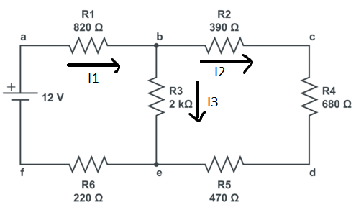
Find I₁, I₂, and I₃
Task02: Solve the following circuit using Kirchhoff’s Voltage Divider Rule.
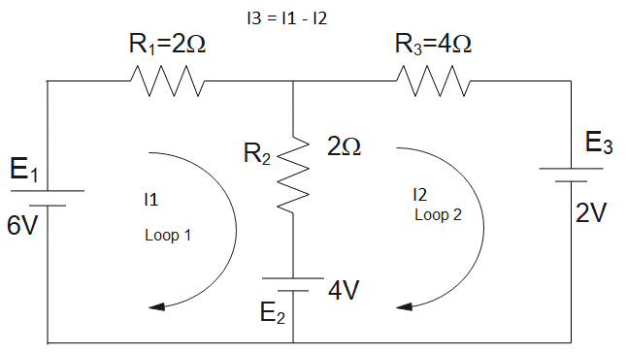
Find I₁, I₂, and I₃.

